1. Create a Basic Calculator (Addition Subtraction,multiplication,Division)

Calculator.html

<!DOCTYPE html>

<html lang="en">

  <head>

    <meta charset="UTF-8" />

    <meta http-equiv="X-UA-Compatible" content="IE=edge" />

    <meta name="viewport" content="width=device-width, initial-scale=1.0" />

    <script src="calculator.js"></script>

    <link rel="stylesheet" href="calculator.css" />

    <title>Calculator</title>

  </head>

  <body>

    <div class="calculator-body">

      <h1>Calculator</h1>

      <div>

        <div

          style="

            display: flex;

            justify-content: center;

            align-items: center;

            margin-bottom: 15px;

          "

        >

          <input

            class="inp"

            type="text"

            placeholder="Enter First number"

            id="num1"

          />

          <input

            class="inp"

            type="text"

            placeholder="Enter Second number"

            id="num2"

          />

        </div>

        <div class="btn">

          <input

            class="btn1"

            type="button"

            value="Addition"

            onclick="calculate(1)"

          />

          <input

            class="btn1"

            style="cursor: pointer"

            type="button"

            value="Subtraction"

            onclick="calculate(2)"

          />

          <input

            class="btn1"

            style="cursor: pointer"

            type="button"

            value="Division"

            onclick="calculate(3)"

          />

          <input

            class="btn1"

            style="cursor: pointer"

            type="button"

            value="Multiplication"

            onclick="calculate(4)"

          />

          <input

            class="btn1"

            style="cursor: pointer"

            type="button"

            value="Clear"

            onclick="clr()"

          />

        </div>

        <div

          style="display: flex; justify-content: center; align-items: center"

        >

          <input class="inp" type="text" placeholder="Result" id="result" />

        </div>

      </div>

    </div>

  </body>

</html>

Calculator.css

.calculator-body{

    display: flex;

    justify-content: center;

    align-items: center;

    flex-direction: column;

    padding: 5px;

    margin: 5px;

    height: 90vh;

}

.btn{

    display: flex;

    justify-content: center;

   margin-bottom: 20px;

}

.btn1{

    padding-bottom: 5px;

    margin-bottom: 10px;

    border: 1px rgba(255, 250, 240, 0.212) rgba(0, 0, 0, 0.192);

    border-radius: 5px;

    width: 100px;

    height: 25px;

    background: transparent;

    cursor: pointer;

    margin-right: 10px;

}

.inp{

    text-align: center;

    height:25px;

    border-radius: 5px;

    margin: 10px;

    padding: 8px;

}

Calculator.js

function calculate(p1){

    let val1 = document.getElementById("num1").value;

    let val2 = document.getElementById("num2").value;

    let res=0

    if (p1 == 1)

    {

        res=parseFloat(val1)+parseInt(val2)

    }

    else if (p1 == 2)

    {

        res=parseFloat(val1)-parseInt(val2)

    }

    else if (p1 == 3)

    {

        res=parseFloat(val1)/parseInt(val2)

    }

    else if (p1 == 4)

    {

        res=parseFloat(val1)\*parseInt(val2)

    }

    console.log(res)

    document.getElementById('result').value = res;

}

function clr() {

    let res = document.getElementById('result').value = ' ';

    let val1 = document.getElementById("num1").value = ' ';

    let val2 = document.getElementById("num2").value= ' ';

}

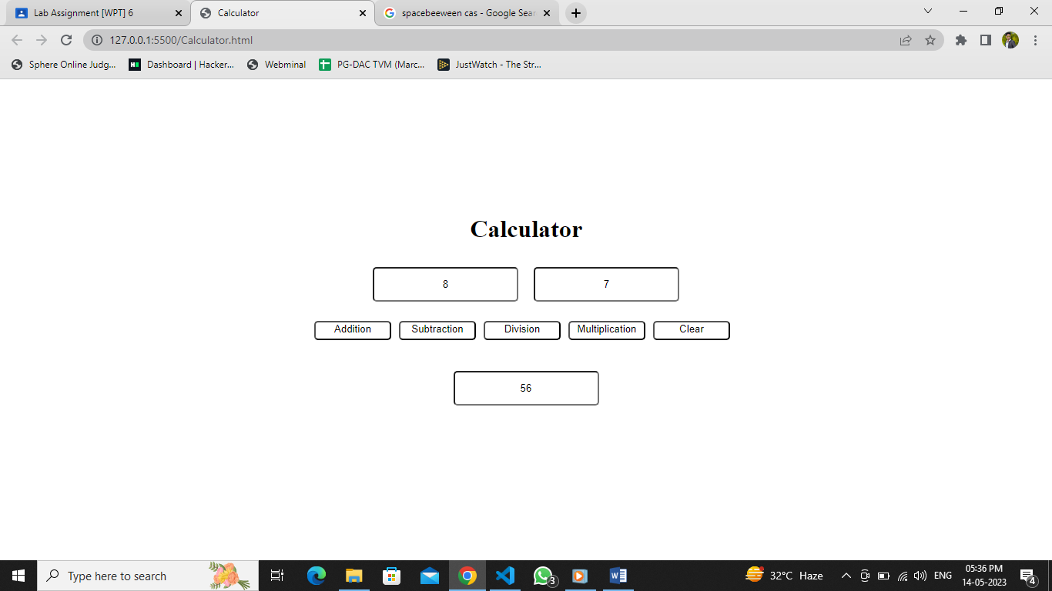

1. Create a Messaging App using html,css,jQuery (WhatsApp demo)

Chatapp.html

<!DOCTYPE html>

<html lang="en">

  <head>

    <meta charset="UTF-8" />

    <meta http-equiv="X-UA-Compatible" content="IE=edge" />

    <meta name="viewport" content="width=device-width, initial-scale=1.0" />

    <link rel="stylesheet" href="chatapp.css" />

    <link

      href="https://cdn.jsdelivr.net/npm/bootstrap@5.3.0-alpha3/dist/css/bootstrap.min.css"

      rel="stylesheet"

      integrity="sha384-KK94CHFLLe+nY2dmCWGMq91rCGa5gtU4mk92HdvYe+M/SXH301p5ILy+dN9+nJOZ"

      crossorigin="anonymous"

    />

    <script src="chatapp.js"></script>

    <title>Document</title>

  </head>

  <body>

    <div class="header">

      <div class="container">

        <input

          class="form-control form-control-lg mt-2 mb-2"

          type="text"

          name="message"

          id="msg"

          placeholder="Type message"

        />

        <input

          class="btn btn-sm btn-success w-25"

          type="button"

          value="Send Message"

          onclick="send(false)"

        />

        <input

          class="btn btn-sm btn-success w-25"

          type="button"

          value="Reply Message"

          onclick="send(true)"

        />

        <div id="msgbox"></div>

      </div>

    </div>

  </body>

</html>

Chatapp.js

function send(p1) {

    let presenttag = document.getElementById('msgbox');

    let exstingvalue = presenttag.innerHTML;

    let boxtag = document.getElementById('msg');

    let message = boxtag.value;

    let position = p1 ? "end" : "start";

    let newValue = `<div class="fs-5 text-success mb-2" style="display: flex; border-radius: 5px;  justify-content: ${position}"> ${message}</div>`;

    presenttag.innerHTML = newValue + exstingvalue;

    boxtag.value = ' ';

}

Chat app.css

body{

    background-image: url('./back.jpg');

}

.header{

   display: flex;

   flex-direction: column-reverse;

   justify-content: flex-start;

}

